Chapter 8, Problem 83.

Figure 8.124 shows a typical tunnel-diode oscillator circuit. The diode is modeled as a nonlinear resistor with i_{D} = f(v_{D}), i.e., the diode current is a nonlinear function of the voltage across the diode. Derive the differential equation for the circuit in terms of v and i_{D}.

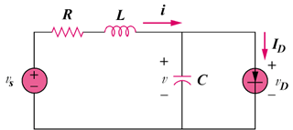

Figure 8.124
For Prob. 8.83.

